English words in Polish…

PIZZA 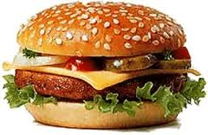 COMPUTER
DVD SNOWBOARD
TENNIS HAMBURGER
HOD-DOG SKATEBOARD
TOSTER TOST
JEANS TRENDY
HIP-HOP DOCTOR
JEEP SHOW
VIDEO ZERO
COOL START
TOILET
